Accumulator – Special purpose register for computation

Microprocessor – CPU is in one chip

Microcontroller – Microprocessor + memory in one chip

Firmware is **software that provides basic machine instructions that allow the hardware to function and communicate with other software running on a device**.

Basic instructions to allow hardware to communicate with the software.

OPCODE – Operation Code

BIOS – Rom – Hard disk – Partition table –

**Bootable and non bootable**

Normal Pen drives are only used for Files sharing. But if we want to install some Operating System. Then we need bootable pendrives. Normal Pendrives can’t do that. When we boot a normal pendrive, then we convert it into Disk Drives as per for computer….

**Normal Pendrive :**In a normal pendrive you can copy your data on the pendrive but the contents will be accessible only when the user is logged into an operation system and accesses the pendrive through it. A normal pendrive may contain files such as mp3, Jpeg, pptx, doc, psd, wav etc or folders that have either been created by the user or directly copied onto the drive.

**Bootable Pendrive** : A bootable pendrive is a type of pendrive in which the contents can be read from that pendrive and loaded at the time of **boot.**The OS will successfully recognize the bootable medium(pendrive) and will report the user that it can boot from that medium(pendrive) instead of a hard-drive, hence the name **bootable**pendrive.

High speed – low latency

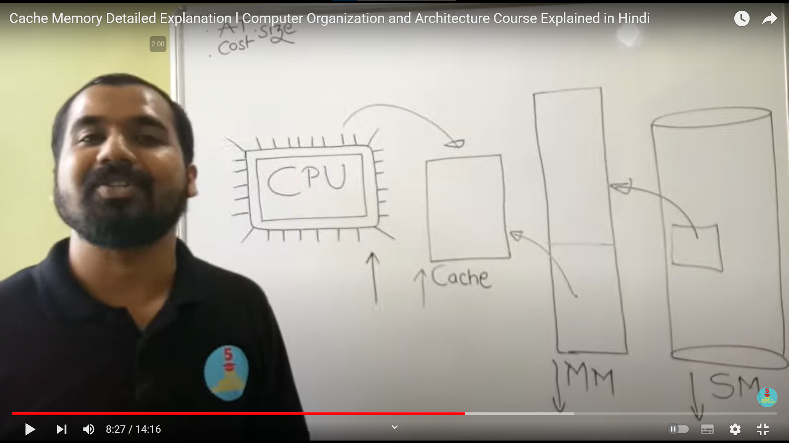

Hit and miss

Recently and frequently data is stored in Cache memory

HL register – High low register

A dirty bit is a **bit in memory switched on when an update is made to a page by computer hardware**. 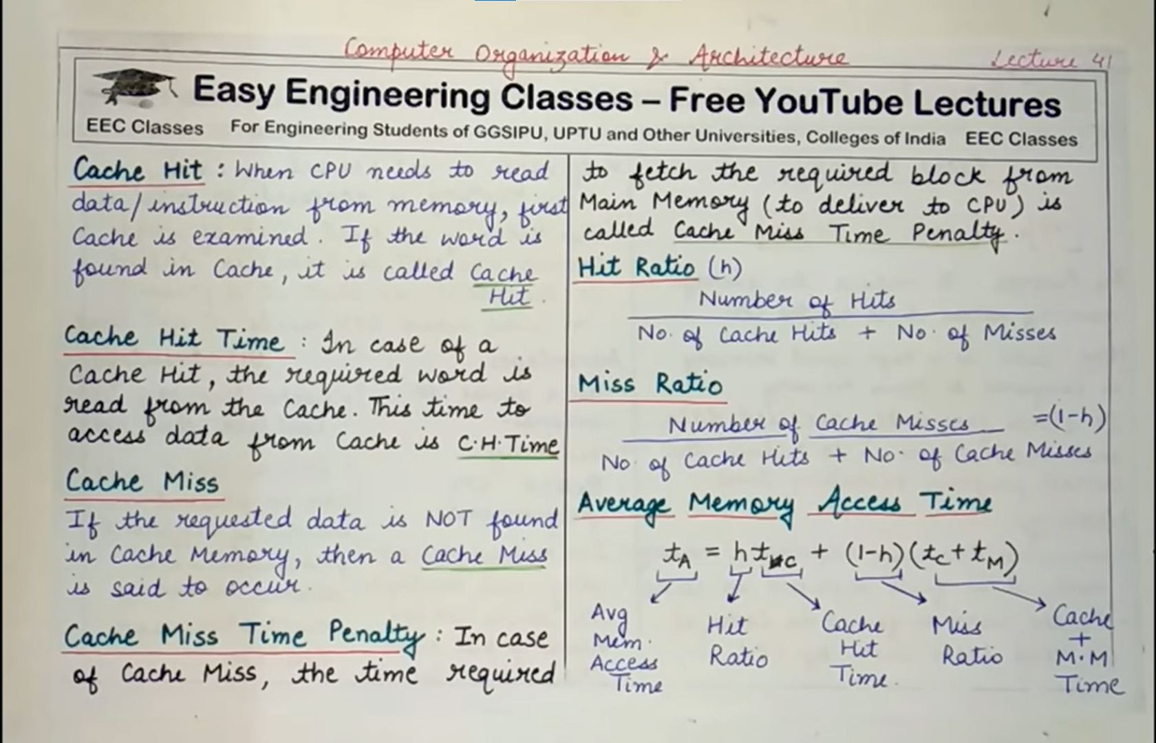



Learn as it is

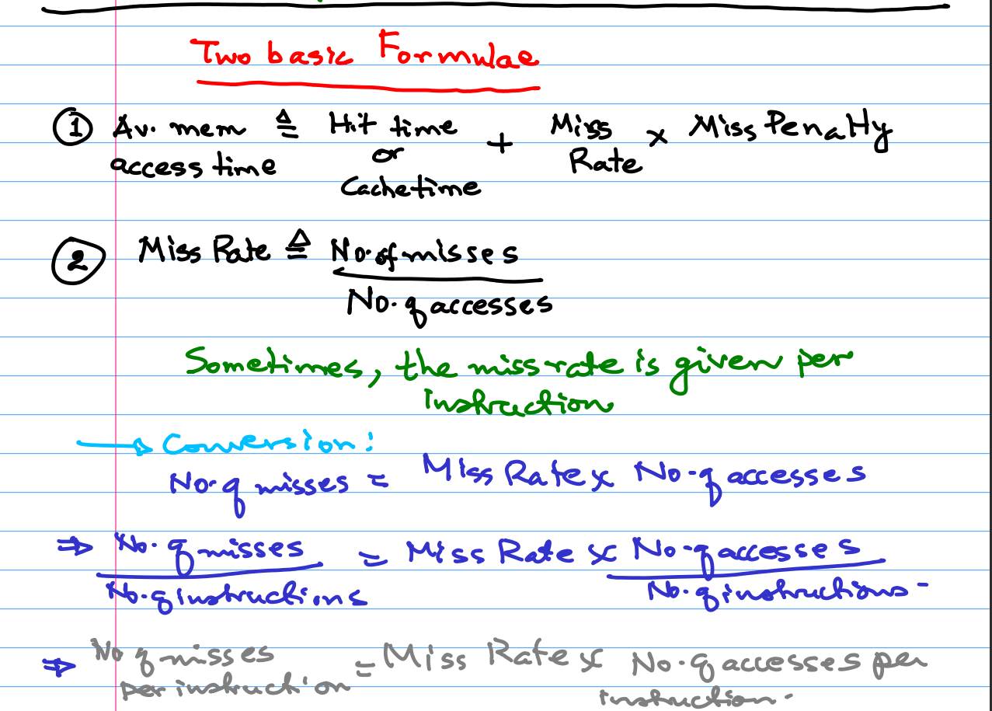

**Write Through –** simultaneously updating in both Cache and Main memory

**Write Back –** At the end, before block replacement, update in Main memory

**Write Update –** update all copies in all private caches

**Write Invalidate –** after updating the value in one of the private cache, update the value in rest of the private caches to invalid state.

**Modified – Shared – Invalid**

What does dirty mean in cache?

A bit in a memory cache or virtual memory page that has been modified by the CPU, but not yet written back to storage. Also used for other temporary purposes, a dirty bit is always a bit in RAM.

Kernel – Part of OS which is always in the main memory

Page – Block in virtual memory

Frame – Block in main memory

My understanding is that a write-miss occurs when we want to write data to a location in main memory whose data is not currently in its corresponding cache block.

This is similar to a read miss: if the cache block that a memory location is mapped to does not contain the data of that memory location (indicated by differing tags), then some other memory location also mapped to that same cache block is currently present, and a miss occurs.

Similarly, we "miss" on a write if the memory location we want to write to isn't currently "in" its corresponding cache block, but rather, some other memory location's data currently occupies it.

The important question that follows a write-miss is "do we update the cache block corresponding to the memory location we just updated with that new data, or leave the old?" Perhaps the memory-location's data already occupying that cache block is more useful or being used more frequently than what we just wrote.

